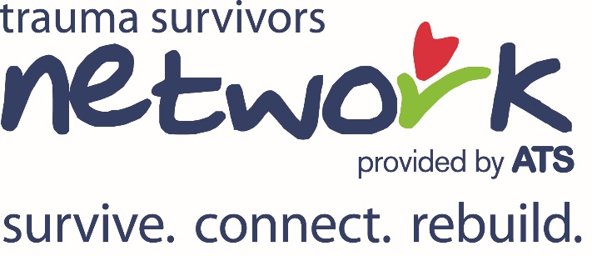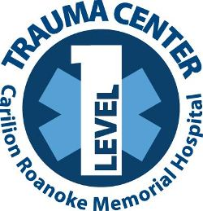

TSN Caregiver Connection
Where & When: 2:00 every Thursday at the Sweet Donkey Coffee Shop
Hosted by Carilion Trauma Services. The purpose is to provide family members and caregivers of trauma survivors an opportunity to take a self-care break. Come join us for coffee/tea and yummy food at Sweet Donkey Coffee, a perfect space for a relaxing break and where family members and caregivers can meet and offer support to one another.
Take a short walk from Roanoke Memorial Hospital, perfect for stretching your legs and getting some fresh air but close enough to the hospital that you can easily make it back if you get called.

