National Trauma Survivors Day 2024 Toolkit
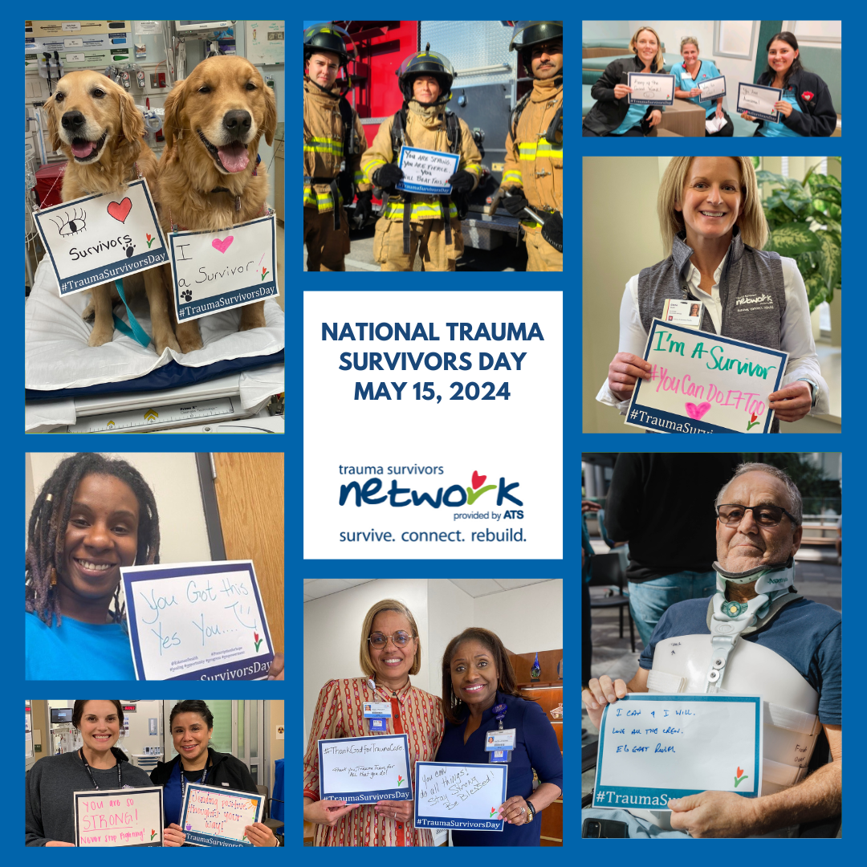

When is NTSD? | May 15, 2024
What is NTSD? | A day to celebrate survivors of traumatic injury
How To Get Involved: | We invite trauma centers, survivors and their communities to celebrate the strength and determination of trauma survivors. There are many different ways to participate.

We are very excited to get Trauma Centers worldwide involved in NTSD. It is a wonderful way to celebrate survivors, their families and /friends and the health care teams.
NTSD is a day we come together and honor the strength, courage and hope that those impacted by trauma show every day in the healing process.
In this toolkit, we will provide some ideas of how you can celebrate at your Trauma Center!
NTSD Communications Toolkit available on the ATS website here.
We hope you’ll find this toolkit helpful as you start to promote NTSD at your trauma center.
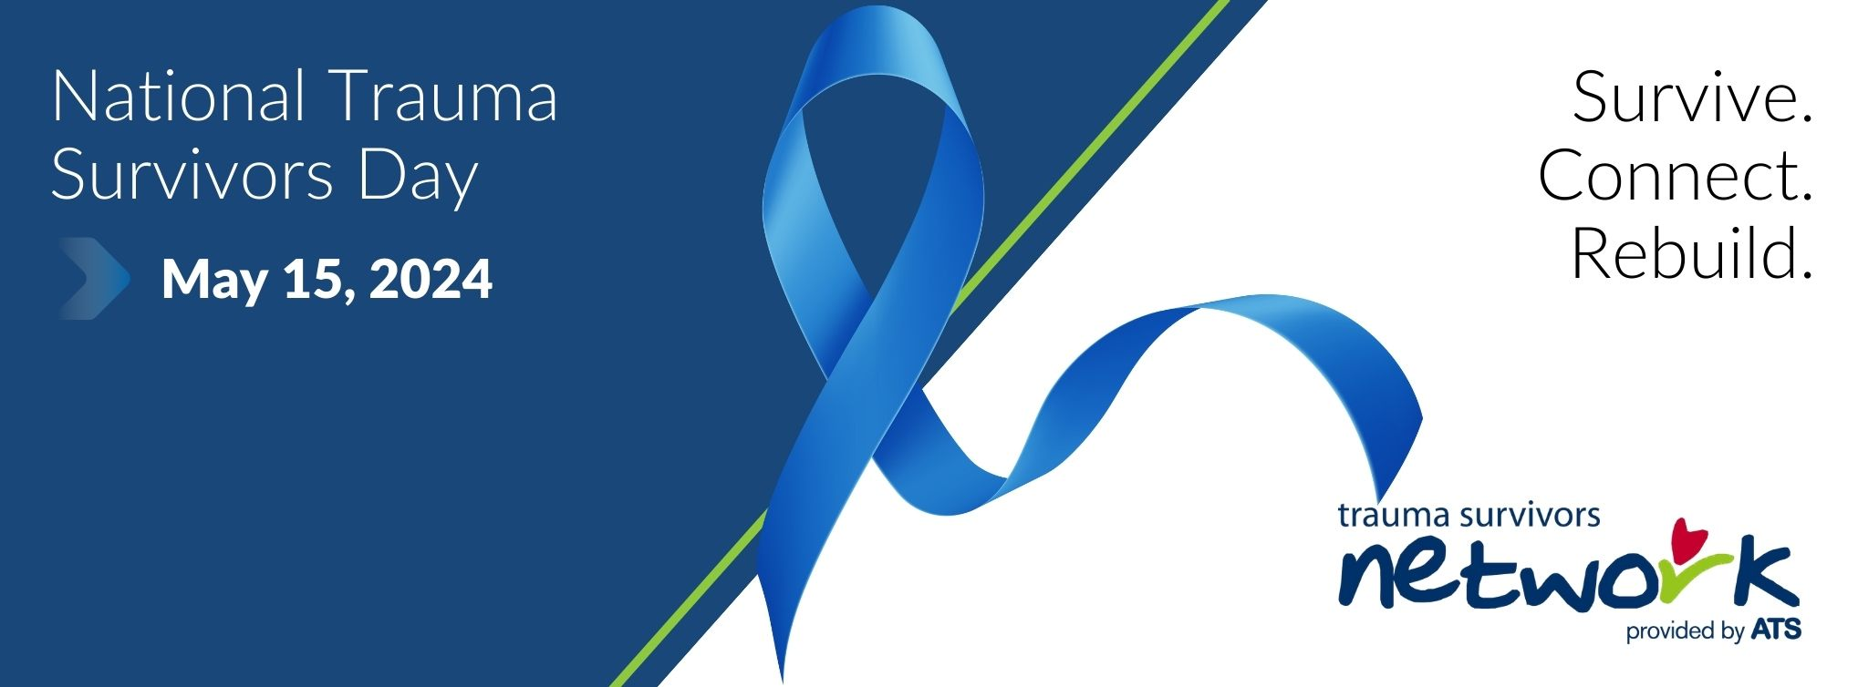

How to Celebrate and Raise Awareness
Here we have listed some ideas and details on various ways to celebrate Trauma Survivors Day. Be creative. Adapt this to your time and budget. Even a small act of kindness or appreciation can bring about great results.
Social Media/NTSD Sign
Individuals or groups can use Instagram, Twitter or Facebook to tell their story or celebrate a survivor. Print this sign write your message, take a selfie and upload it to any of the social media sites using #TraumaSurvivorsDay and #NTSD. You can also email your picture to the ATS at admin@traumasurvivorsnetwork.org.
This is an easy way for survivors, families, and trauma teams to participate on their own, or as a group. Some hospitals have social media accounts and may be very interested in partnering with you for this activity. It is important to include your Communication/PR department in this activity if you are taking pictures on site. They will have the photo release forms necessary for taking and posting pictures. They can advise you on any other privacy concerns.
A national virtual photo booth will be launched in May. Stay tuned for more information on how to add your photo!
Advice from TSN coordinators
- Create pre-written messages on signs in case participants have a hard time thinking on the spot
- Provide signs and markers to team members in their breakroom or other convenient location
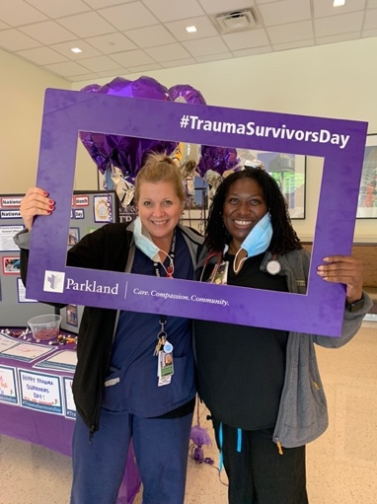
- Take photos of people holding the signs before NTSD so that your marketing staff can use those for on the actual day
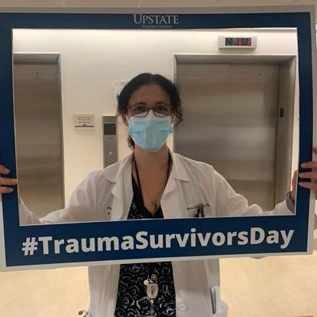
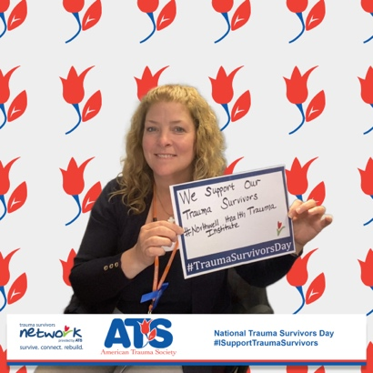
- Create a custom printed selfie board to get people involved

Spread the Word
Setting up a TSN information table is an easy way to spread the word about National Trauma Survivors Day and inform staff and visitors of the TSN program. Work with your hospital administration team to receive approval to set up a “health fair” style table. Set up in an area with high traffic such as near the main entrance or cafeteria. Your table can include TSN promotional materials, local resources and a fun backdrop for people to take pictures with the NTSD sign for a social media campaign. Add some TSN swag such as pens, candy, hand sanitizers, etc. with the TSN and your hospital’s logo. Most importantly, reach out to some survivors and family members and see if they are available to spend time at the table so that visitors can have face to face interaction with people who have first-hand experience with the benefits of the TSN program. This is an easy way to promote the TSN program especially at sites who are newly starting the program.
**For TSN swag for purchase, please visit here.
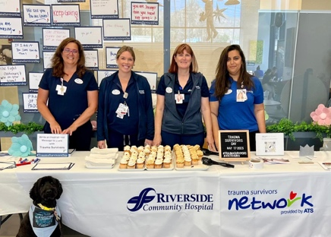
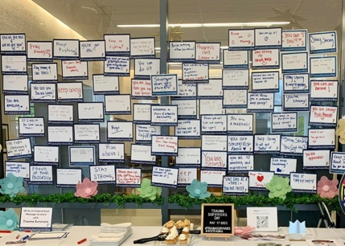
Ideas from fellow TSN coordinators
Riverside Community Hospital set up in the hospital cafeteria with opportunities to write a message and display on the wall. An added touch was getting cupcakes to distribute (which you could get donated by local organizations).
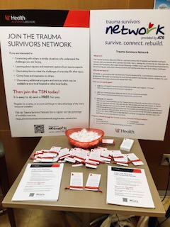
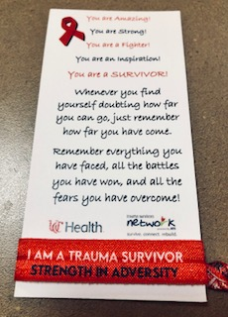
UC Health Cincinnati, set up an info table and handed out TSN bracelets to patients and families with a note of encouragement.

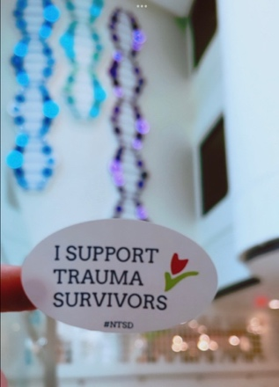
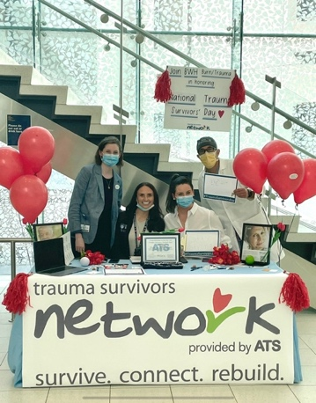
Brigham Women and Children’s set up an info table at the hospital entrance and distributed resources as well as TSN stickers.

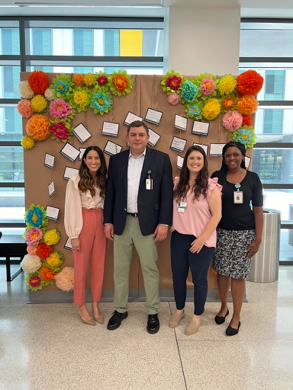
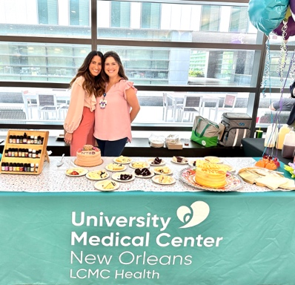

University Medical Center New Orleans set up a fun photo backdrop and a table with bracelets of positivity and cake.

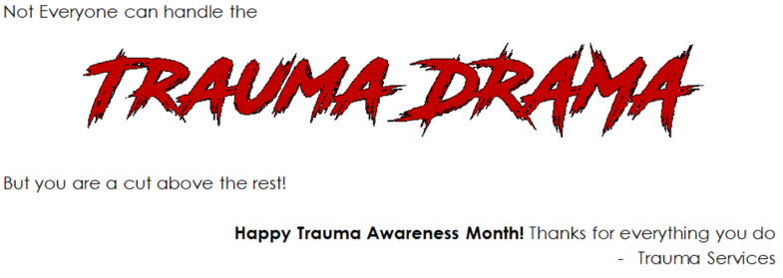
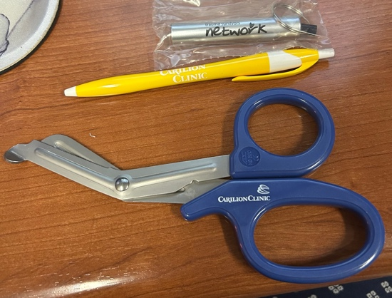
Carilion Roanoke Memorial Hospital had TSN and hospital branded trauma shears made and distributed to trauma staff with a clever pun.

- Participate in the Race to Rebuild
Race to Rebuild is a virtual Walk/Run/Cycle/Roll distance of your choice event that anyone can take part in anywhere and anytime between May 1st and May 31st. All participants will receive a Race to Rebuild t-shirt and other TSN swag. More information coming soon!
Gather a team within your hospital and in your community. Set a date and time for individuals to meet and complete a walk/run/cycle/roll distance of your choice. Map out the distance at a local park or even on your trauma center campus. Encourage participants to wear their Race to Rebuild swag and invite your Communication/PR department in this activity if you are taking pictures on site.
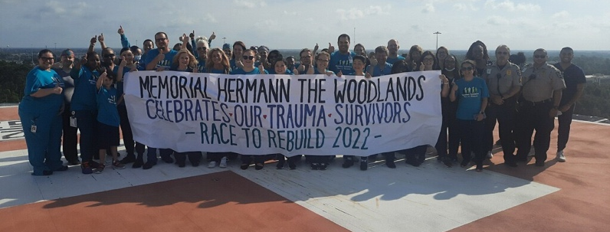
Ideas from fellow TSN coordinators
Memorial Hermann the Woodlands organized a 1 mile walk around the hospital campus and a ceremony on the helipad.
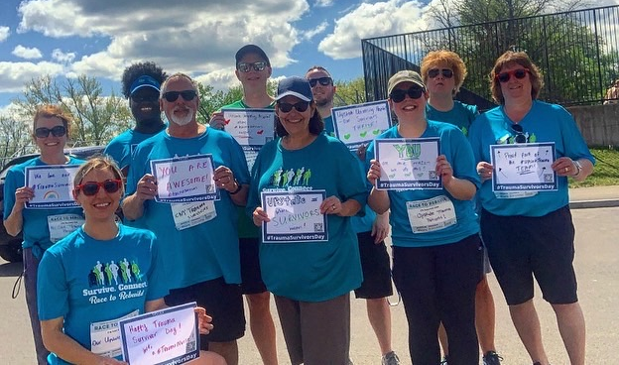
Upstate University Hospital, organized an in-person walk at a local park where participants also wrote a message of hope to trauma survivors.

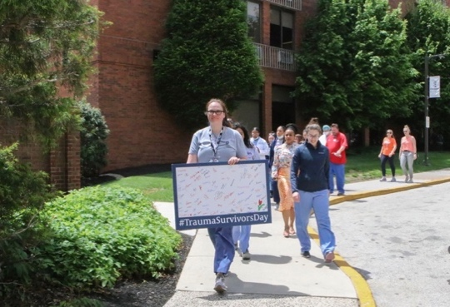

Einstein Medical Center organized an in-person walk around the hospital campus.

Survivor Reunion, Reception or Picnic
Survivor reunions, receptions, picnics, or socials give your trauma center an opportunity to bring your local survivors and trauma teams together for support and celebration. Create a flyer inviting survivors, their family/friends, and trauma teammates to your event. It can be a simple drop-in or can be more formal. It’s up to you and your team. Just mail or e-mail your flyer or invitations to several discharged trauma patients who are in your local area. Ask your volunteer services if they can help provide volunteers to help prepare the mailing. Take flyers to the rehabilitation center or outpatient trauma clinics where trauma patients return for ongoing follow-up appointments. Ask TSN Peer Visitors or even trauma team members to help volunteer with set up, clean up, etc.
This can be an inexpensive way to celebrate together. Have fun! Bring some balloons. Make it a party. Invite your trauma center’s pet therapy team to come. If you have an established peer support group, this can be in place of a current support group meeting or in addition to the group meeting. You may want to partner with other organizations such as brain injury, spinal cord injury, or amputee groups and celebrate together.
Whether big or small, this event will need prior planning and we recommend partnering with your Communications/PR department. They should have experience marketing these kinds of events at your trauma center. A more formal reception could include 1 or 2 survivors who share their stories. Both survivors and specific care team members could receive recognition gifts. It is a wonderful way to celebrate the work of both the trauma healthcare professionals and the hard work the survivors put into their own recovery.
Ideas from fellow TSN coordinators
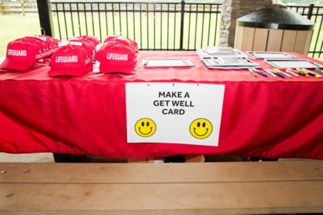
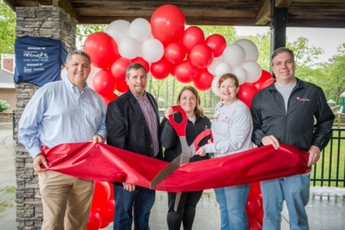
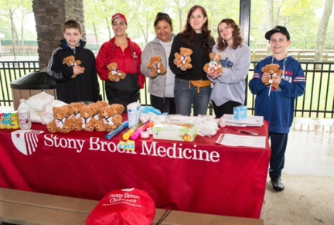
Stony Brook University Hospital had their first event! On a small budget, they worked to source decoration such as a balloon arch. Their community relations team assisted in providing table cloths, signage, etc. They had a teddy bear clinic and a make a get well card station which were later provided to trauma patients.
Morristown Medical Center coordinated Bracelets of hope. Participants were invited to make a bracelet to take home or donate back to the trauma staff and patients and families.
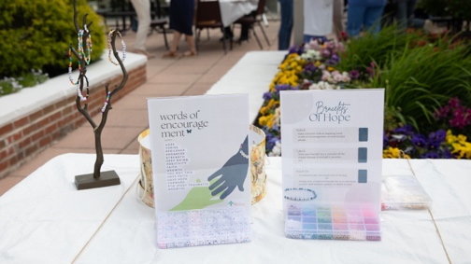
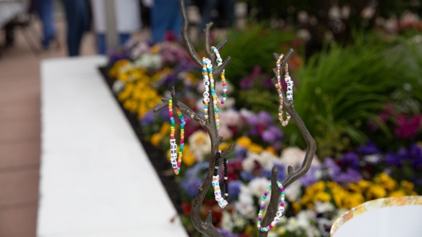

Partner with a local sports team or local event
Partnering with a local sports team or local event can be an excellent way to spread community awareness of the TSN program and offer a fun time for trauma survivors and trauma staff to get together. Have a local sports team near you? Find out how you can collaborate to bring the TSN to their ball field, court, etc. Have a local event like a 5K or blood drive happening? Find out how your local TSN program can support their efforts.
Ideas from fellow TSN coordinators
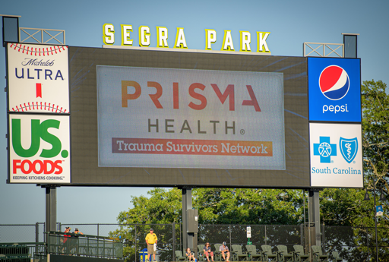
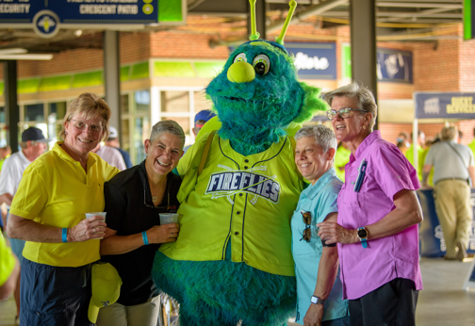
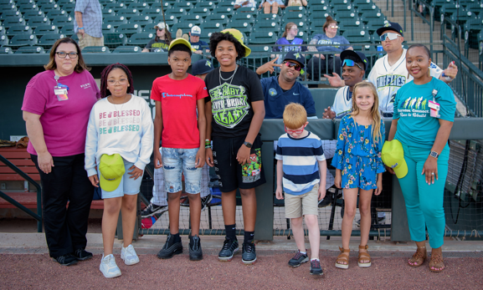
Prisma Health Richland and Children’s hospital organized a night at the local minor league baseball field. They were able to receive discounted group tickets and invited staff, trauma survivors and their families. The kids who attended, some of which were survivors, got to run out on the field at half time and the TSN and trauma center logo was displayed throughout the game. A trauma survivor threw out the first pitch!

IU Health helped arrange for a trauma survivor to be the green flag delivery honoree of the 106th Indy 500 race – read more here.
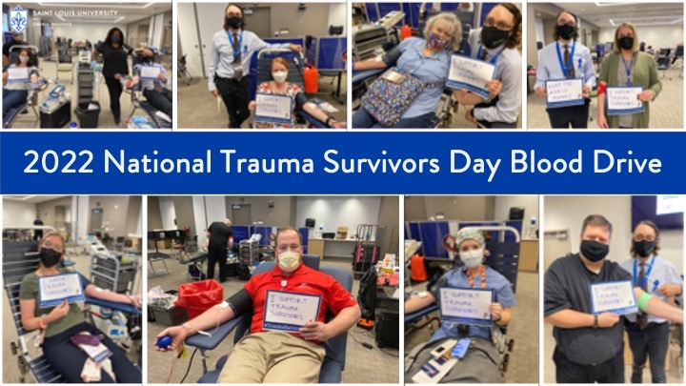
St. Louis University Hospital organized a blood drive on National Trauma Survivors Day. Donors were encouraged to write a message for trauma survivors and take pictures and goodies for all.

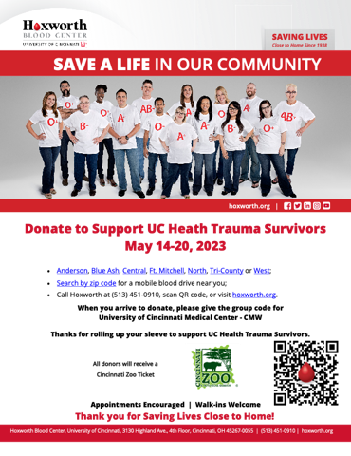
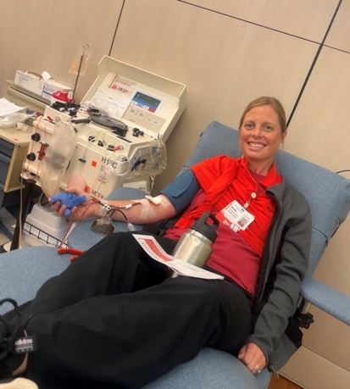
UC Health in Cincinatti hosted a virtual blood drive where donors could donate on behalf of the Trauma Survivors Network.

Tulip Garden
The red tulip in the ATS and TSN logo symbolizes that despite challenges and set backs, there can be growth and beauty after trauma. One way to honor our trauma survivors and health care professionals during Trauma Awareness Month is to create a tulip garden. If tulips don’t bloom in May in your area, consider purchasing garden stakes in the shape of tulips or artificial tulips.
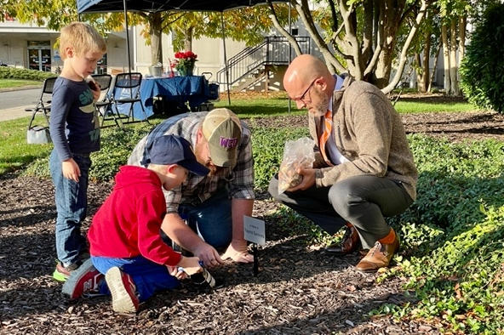
Ideas from fellow TSN coordinators
Reading Hospital hosted a Blooming after injury tulip planting ceremony where survivors and the community were able to plant a bulb in honor or memory of someone. Learn more here.
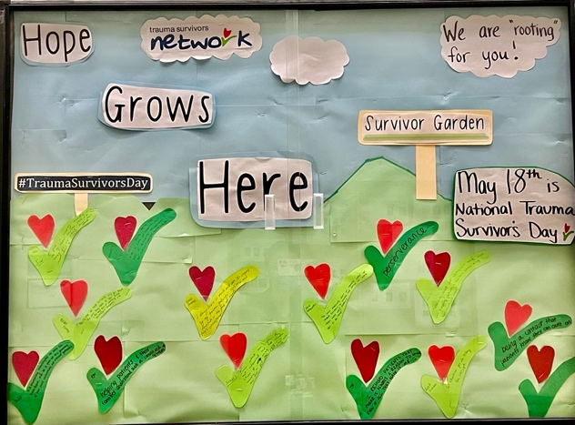

Brigham Women and Children’s created a paper tulip garden where staff could write messages of hope and inspiration to hospitalized patients.

Peer Visitor Mentor Recognition Lunch or Dinner
Recognizing the commitment and time of survivors who volunteer as TSN Peer Visitors is important. One way to show your thanks is by inviting TSN Peer Visitors to a special lunch or dinner. This event will have some costs associated. You may want to hold this at the hospital with catering or you may want to reserve a meeting room in a local restaurant. Ask a respected surgeon to come share as a special speaker. Invite trauma nurses and surgeons to attend. Take a special group picture of your TSN Peer Visitor team. Create an award or certificate to honor each Peer Visitor individually. It is a time to recognize the countless hours of volunteering that Peer Visitors gave over the past year. The heart of the TSN is truly the dedicated survivors and family members who share their stories and help connect with others in need.
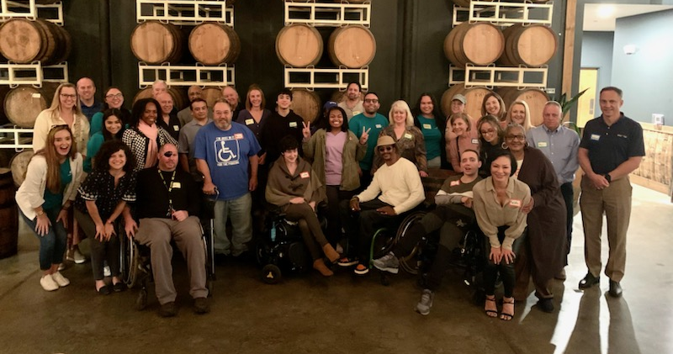
Ideas from fellow TSN coordinators
The Atrium Health team in Charlotte, NC organized a peer visitor recognition dinner. Survivors are encouraged to bring their families to that all trauma staff can get to know their volunteers and their loved ones.

Survivors Giving Back
Survivors often want the opportunity to “pay it forward” or to say “thanks” to their trauma teams who gave them life- saving care. This is a wonderful and informal way to make that happen. Organize a snack donation drive to create baskets of goodies for the trauma staff members. Identify the number of floors, units, or departments that you are interested in thanking. This would be a great group activity to do during a TSN Survivors Group! Working with your survivors, put the baskets together and create a sign or card that your survivors could all sign for each trauma unit or trauma team. Come help your survivors deliver the baskets and cards/signs to the trauma floors. This can be done on a small budget and with little lead time.
Trying to Grow your Program?
- Build Support for your TSN program: Use this campaign to create awareness and support within your trauma center for these new TSN program initiatives.
- Community Involvement: Work with your center’s marketing and personal relations to get a press release out about your program and National Trauma Survivors Day

2023 TSN in the News!
- https://news.vumc.org/2023/06/15/vumc-celebrates-trauma-survivors-and-their-care-providers/
- https://news.stonybrook.edu/university/hospital-holds-first-ever-journey-to-healing-event-for-trauma-survivors/
- https://www.mytwintiers.com/news-cat/national-trauma-survivors-day-at-guthrie-robert-packer-hospital/
- https://www.westernmassnews.com/2023/05/17/trauma-survivor-thanks-baystate-staff-help-provided-after-car-crash/
- https://www.palmbeachpost.com/story/news/local/2023/05/24/survivors-thank-palm-beach-county-trauma-center-medical-teams-that-kept-them-alive/70220559007/
- https://southfloridahospitalnews.com/broward-health-honors-trauma-survivors/
- https://www.floridatoday.com/picture-gallery/news/2023/05/18/trauma-reunion/11892960002/
- https://hellowoodlands.com/memorial-hermann-the-woodlands-hosts-first-annual-trauma-survivors-day-celebration/
- https://www.palmbeachpost.com/story/news/local/2023/05/24/survivors-thank-palm-beach-county-trauma-center-medical-teams-that-kept-them-alive/70220559007/
- https://www.mycentraljersey.com/story/news/health/2023/05/22/rwj-hospital-trauma/70232804007/
- https://www.floridatoday.com/story/news/2023/05/17/brevard-near-death-victims-mark-national-trauma-survivors-day-at-hospital-in-melbourne-florida/70226570007/
- https://www.sun-sentinel.com/2023/05/20/inside-south-florida-ers-gunshots-can-be-deadly-surviving-them-traumatic/
- https://www.12news.com/article/news/local/valley/valley-dad-max-loya-lucky-to-be-alive-after-life-threatening-motocross-accident/75-a19148d4-4b52-4405-99d4-acd7597dd46d
- https://www.wmar2news.com/local/two-patients-at-johns-hopkins-bayview-honored-amid-trauma-survivors-day
- https://www.washingtonpost.com/dc-md-va/2023/11/29/trauma-survivors-dc-hospital/
- https://www.fox5ny.com/news/brookdale-hospitals-trauma-team-celebrated-in-special-ceremony
- https://www.azfamily.com/2023/05/16/chandler-man-who-survived-dirt-bike-crash-thanks-trauma-team-st-josephs/

2022 TSN In the News!
- https://www.41nbc.com/atrium-health-navicent-honors-trauma-survivors-with-special-moment/
- https://www.13wmaz.com/article/news/local/atrium-health-navicent-honors-trauma-survivors-with-award/93-32e095a3-0ddb-4efc-aa7e-f950acab4769
- https://www.maconbibb.us/traumasurvivors52022/
- https://www.wvtm13.com/article/uab-hospital-celebrates-trauma-survivors-ceremony-may-18/40041369#:~:text=GET%20LOCAL%20BREAKING%20NEWS%20ALERTS&text=May%2018%20is%20National%20Trauma,day%20in%20a%20big%20way.
- https://www.wbrc.com/2022/05/19/uab-hospital-celebrates-national-trauma-survivors-day/
- https://fox59.com/indiana-news/local-trauma-survivor-using-her-experiences-to-help-others/
- https://fox59.com/news/indy-rev-money-helps-pay-for-trauma-chaplain-working-for-patients-coworkers/
- https://www.wrtv.com/sports/indianapolis-500/meet-matthew-cheatham-the-green-flag-delivery-honoree-of-the-106th-indy-500
- https://www.winknews.com/2022/05/18/lee-health-honors-former-patients-on-national-trauma-survivors-day/
- https://www.wndu.com/2022/05/18/survivor-shares-story-national-trauma-survivor-day/
- https://southfloridahospitalnews.com/on-national-trauma-survivors-day-florida-survivors-reflect-on-roads-to-recovery-in-hopes-of-inspiring-others/
- https://www.whas11.com/video/news/local/louisville-officials-recognize-national-trauma-survivors-day/417-de47d9a4-b9d5-4f73-9d39-5d8020e86e6e
- https://www.wmar2news.com/middaymaryland/maryland-traumanet-trauma-awareness-month
- https://www.woodlandsonline.com/npps/story.cfm?nppage=72959
- https://southfloridahospitalnews.com/broward-health-celebrates-trauma-survivors-caregivers/
- https://fox59.com/news/trauma-survivor-reunites-with-riley-surgeon/

