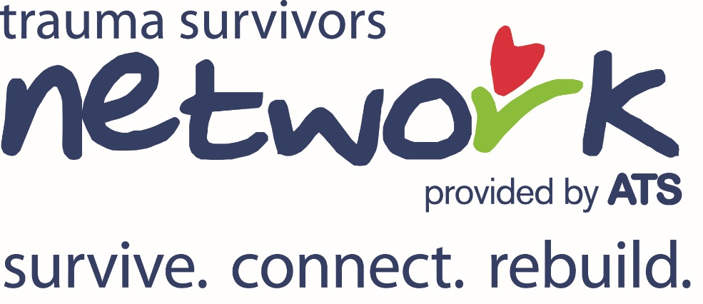
Trauma Survivors Network (TSN) Referral Guidelines
Please refer trauma patients to the Trauma Survivors Network coordinator if they meet one of the following guidelines:
- Life-altering injury from traumatic mechanism
- Loss of limb/use of limb due to traumatic injury
- Existing mental health process in the trauma patient
- Extended length of stay in hospital/rehab due to traumatic injury
- Death of someone related to same traumatic injury event
- Trauma patient request
- HCP discretion of patient need

Referral does not need to be made during initial hospitalization, can be made in outpatient clinic, unrelated admission or during rehabilitation.

Referral will activate TSN coordinator to reach out to patient to offer recovery resources after a traumatic injury (either in person or via phone/email depending on patient’s admission status).
